D802 – Task 3 | Robert Parham | Student ID: 012420086

Building and Training a CNN to Classify Images

In this task we will be building our model with the PyTorch library and specifically its torch.nn module, which provides the building blocks to build neural networks in Python. For displaying the summary, we will use a separate library called torchinfo (Req B). Torchinfo is built on top of Pytorch and is mean to be used alongside it. Torchinfo outputs information about parameter counts, tensor shapes, and memory usage at each layer.
The summary displays a tabular structure showing each step in the network that the input tensor traverses. The output shape column shows the dimensions of the tensor after each layer in the network. This allows you to trace each 32x32 image as it is transformed through each layer in the network.
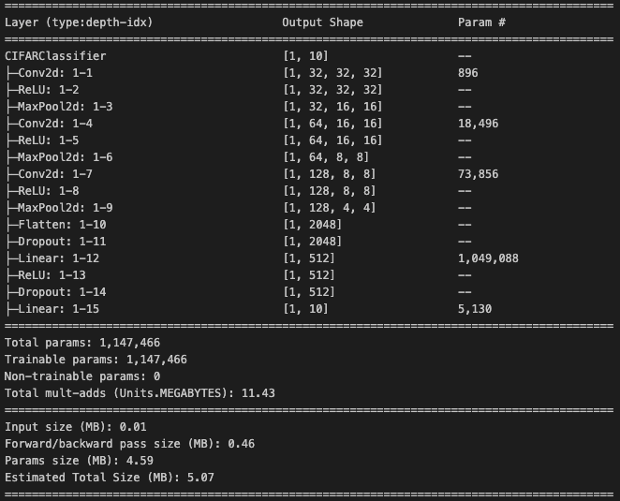
In the model show, we’ve decided to use 6 layer types: Conv2d, which is a convolutional layer that scans the image to detect patterns like edges and shapes. ReLU, which zeroes out any negative values in the input tensor to introduce nonlinearity. MaxPool2d shrinks the spatial dimensions by keeping only the highest values in each region scanned by the convolutional layer. Flatten, collapses the 3D tensor into a single dimension so it can be fed into the fully connected dense layers. Dropout, which randomly zeroes out some of the values to prevent the model from relying too heavily on any single neuron (Req B.1b).
For each convolutional block that detects features of the input image, the shape is [batch_size, channels, height, width], meaning that we fed it 1 image, with 32 channels, and the image is 32 pixels by 32 pixels. The summary shows that spatial dimensions are cut in half after each MaxPool while channel depth doubles until it’s reduced to a 4x4 grid with 128 channels before flattening (Req B.1c).
The parameter number shows how many learnable weights each layer contains. Layers like ReLU, MaxPool, and Dropout don’t have learnable weights because they are fixed mathematical operations that simply restructure or modify data from the previous layer.
The parameter counts in the provided screenshot show us something important. The 3 convolutional layers account for about 93k parameters while the first Linear layer alone contains over a million, which is about 90% of the entire model. This tells us that our model lacks efficiency, which is exactly what the model summary is designed to do, provide visibility and insight into improvements that can be made (Req B.1a).
The 5MB size of the model tells us that it’s relatively small by modern standards, so we have some room to grow if we want to push for better accuracy.
Students should discuss the number and type of each layer in the architecture. For example, there are three convolutional layers, each followed by ReLU activation layer and a MaxPool layer. These are referred to as “Convolutional Blocks.” After the stack of convolutional blocks, a single Flatten layer collapses that tensor into a single vector of values which the Fully Connected Dense layer then uses to produce the final predictions (Req C).
The total parameter count is the most direct measure of a model’s complexity. It tells you how much the model is able to remember. The summary above indicates that the model shown has 1,147,466 parameters, which means that there are over a million parameters being adjusted during the training process. A larger parameter count isn’t indicative of a more accurate model necessarily though. There are diminishing returns with a greater parameter count, and a larger parameter count could put the model at risk of overfitting (Req. D).

